CAB302 – Software Design

Manual Test Case

Kok Fuh Teo (09830642)

Zhi Choon Ng (09056572)

# Additional Test Case

Testing readFile:

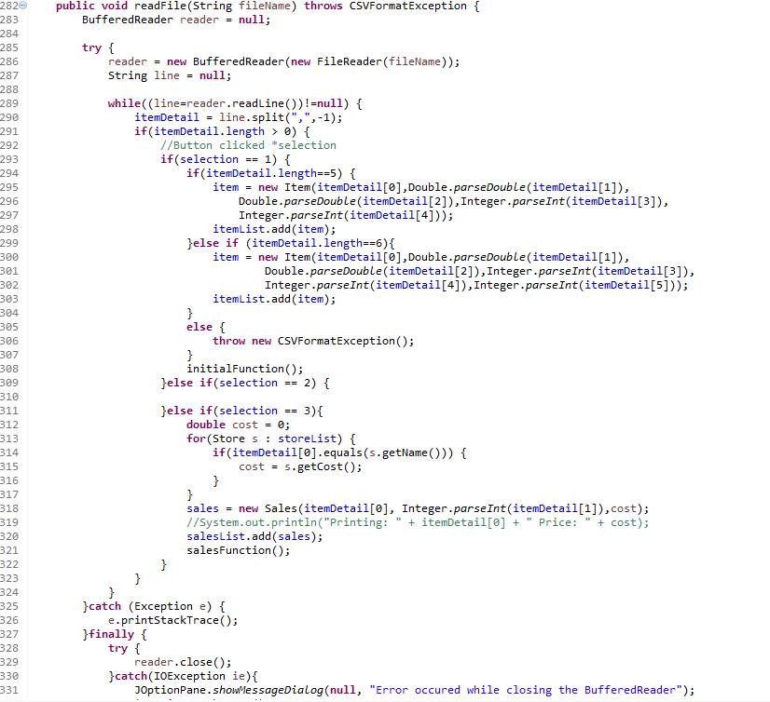

The file is called at this point:

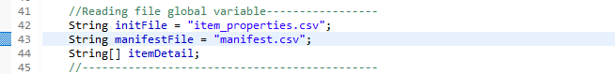

To test if the file is working, we purposely load custom item properties. The test file contains only one line



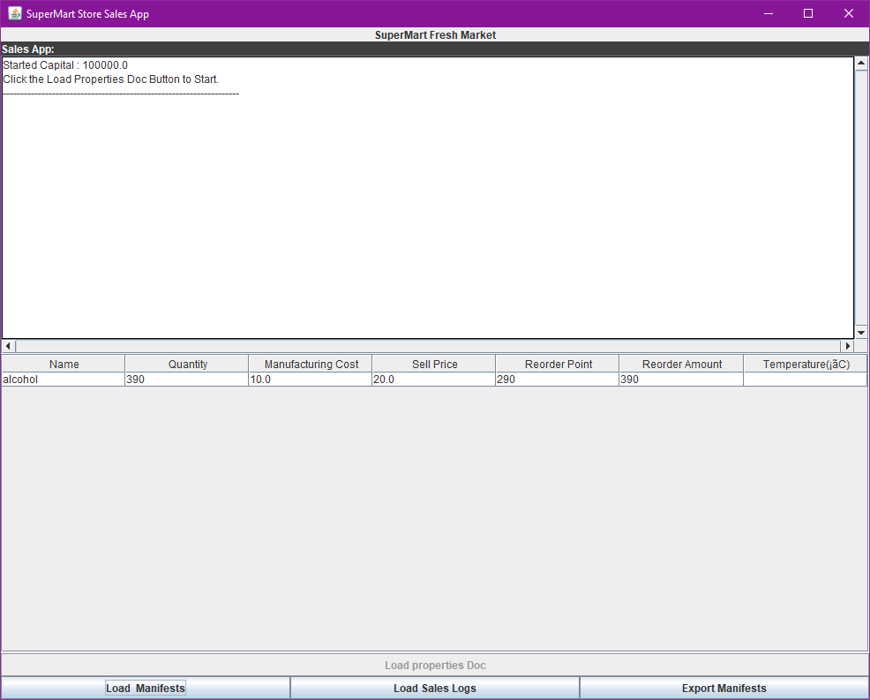

This proves that the item reader works for items with 5 properties.





This proves that the item reader works for item with 6 properties.

Now, we test the CSVFormatException, deliberately using an item_properties.csv that contain only 4 properties.



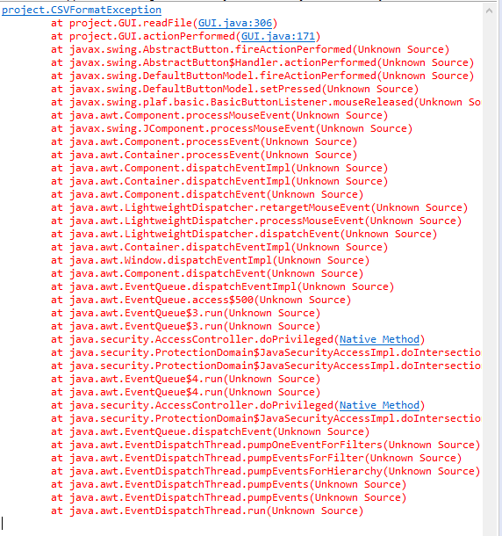

Still need export testing

## Testing CSV File for SalesLogBox

The file is called at this point:

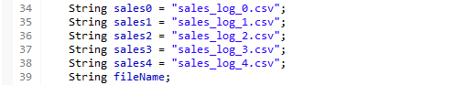

The test file will replace one of the sales. It contains only the following item:



The GUI is then loaded and the Load Sales Logs (GUI BUTTON 3) and the Sales_Log_0 is chosen as it currently holds the test file.

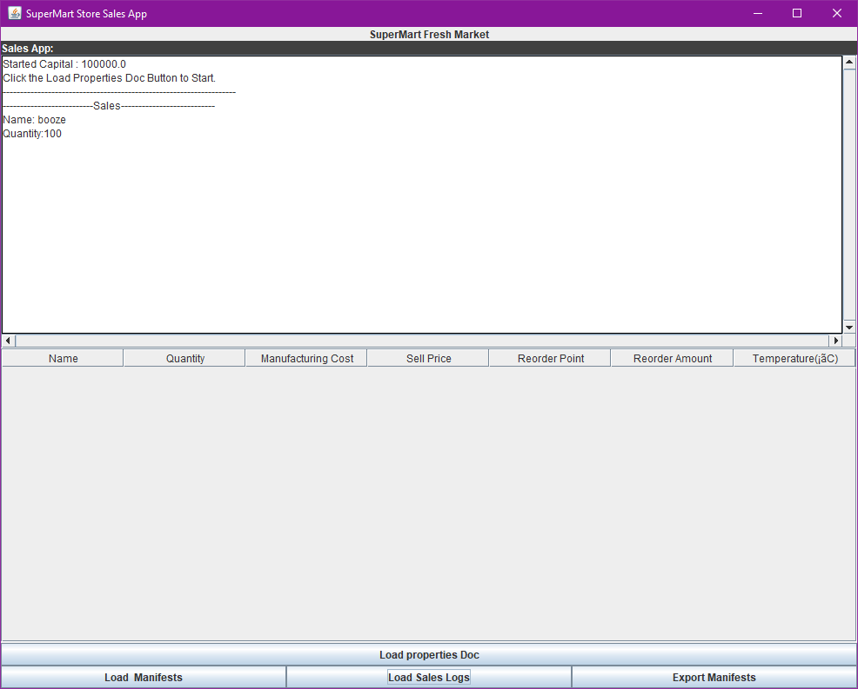

As it can be seen under sales, it prints, indicating it is working as intended. Now we diberately used something of a wrong format.